



Understanding Domestic Violence Against Women in a Rural Area
A Case Study

Pream Balaji
@premfy

Table of Contents

Page
- Research Background & Motivation 3
- Incidence of Domestic Violence by Income 4
- Marital Status Impact 5
- Employment Status Influence 6
- Age and Domestic Violence 7
- Detailed Analysis 8
- Fractional Representation 12
- Conclusion & Recommendations 13

Background

In recent years, domestic violence has increasingly become a pressing issue affecting individuals across various demographics. This case study delves into the correlation between domestic violence and socioeconomic factors, particularly focusing on income distribution and age demographics.

Objective
The primary objective of this study is to explore how domestic violence impacts income levels across different age groups, shedding light on potential socioeconomic disparities associated with domestic violence.

About Dataset
This dataset by Fahmida Choudary contains information on domestic violence against women in a specific rural area of a developing country. The data is collected to help understand the correlation between various socio-economic factors and domestic violence.
3

Incidence of Domestic Violence by Income
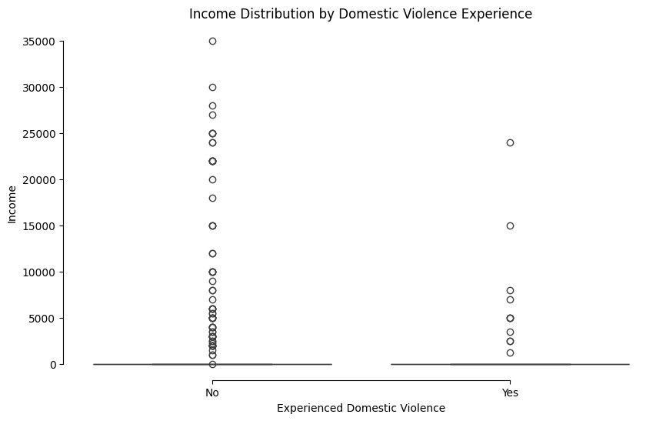
Individuals who experienced domestic violence consistently showed lower income levels compared to those who did not, irrespective of their marital or employment status.

Marital Status
Among both married and unmarried individuals, those who experienced domestic violence had significantly lower incomes than those who did not.

Employment Status
Individuals who experienced domestic violence consistently showed lower income levels compared to those who did not, irrespective of their
employment status. 4

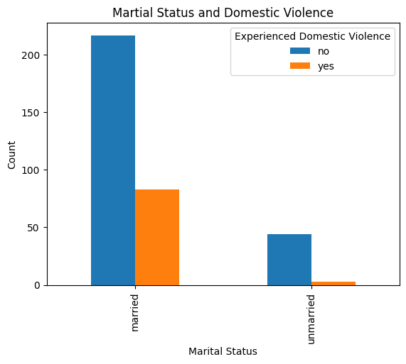
Martial Status Impact

The financial disparity between those who experienced domestic violence and those who did not was more pronounced among the unmarried group.

Unmarried Individuals
Experienced domestic violence were more likely to fall into lower income brackets compared to their married counterparts.

This suggests that being unmarried may exacerbate the economic impact of domestic violence, potentially due to lack of shared financial resources or social support.
5

Employment Status Influence

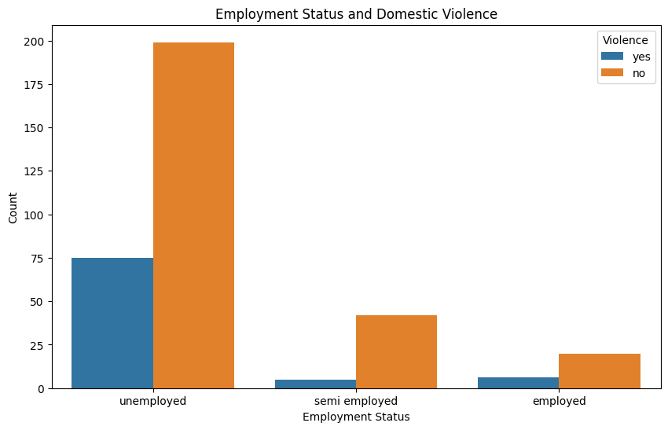
The economic impact of domestic violence was most severe among those without stable, full- time employment.

Unemployed and Semi-employed
are individuals who were victims of domestic violence had significantly lower incomes than those who did not experience violence.

This highlights the critical need for employment support and economic empowerment programs for domestic violence victims to help mitigate financial hardships.
6

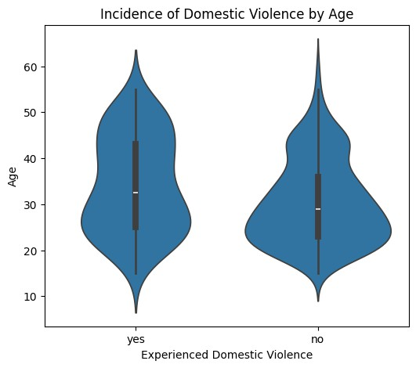
Age and Domestic Violence

The incidence of domestic violence was highest among individuals in their 20s and 30s, with a noticeable decline in older age groups.

Younger victims
Victims in their 20s and 30s also exhibited a wider range of income disparities, often correlating with lower income levels.

The decline in domestic violence incidence with age may reflect changes in relationship dynamics, increased economic stability, or different reporting tendencies among older individuals.
7

Detailed Analysis
Income Distribution by Marital Status and Domestic Violence v
Income Distribution by Employment and Domestic Violence

8

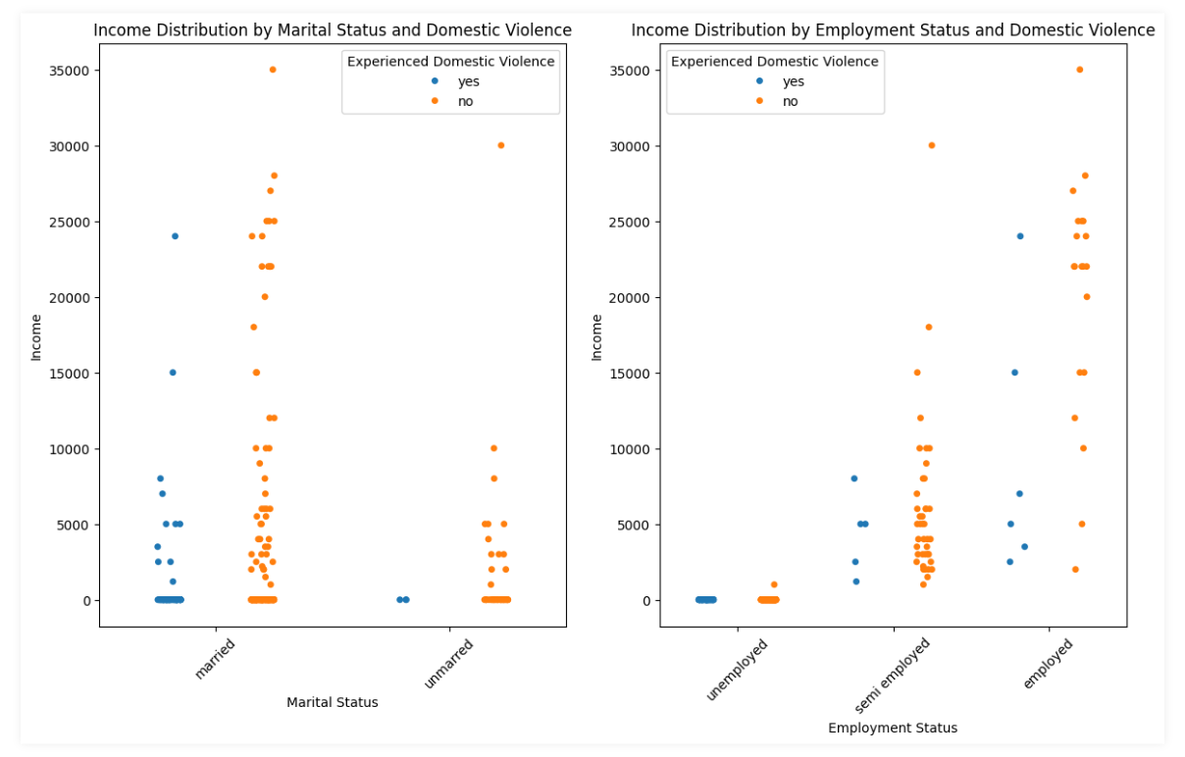

9

Detailed Analysis
Incidence of Domestic Violence (Violin Plot) v
Incidence of Domestic Violence (Swarm Plot)

10

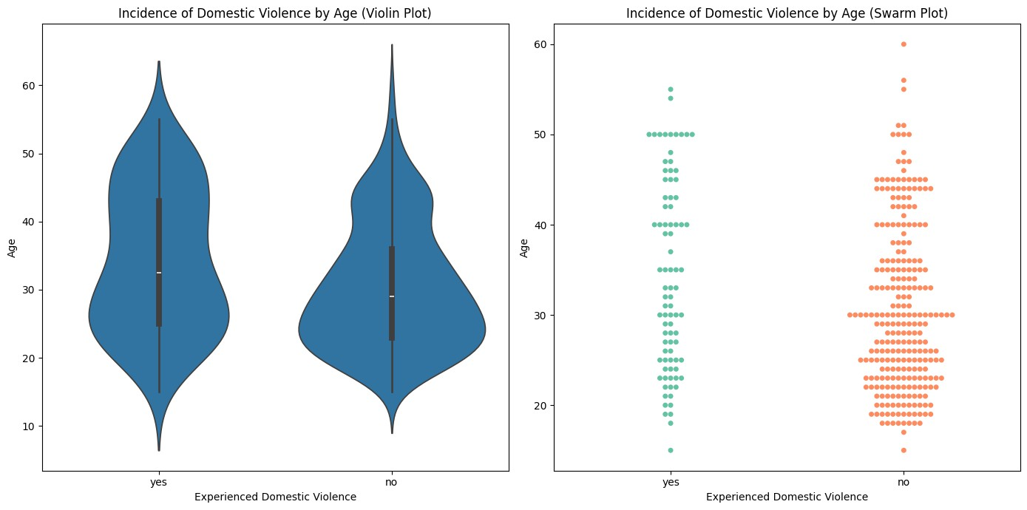
11

Fractional Representation

1 IN 3
In rural areas, approximately 1 in 3 individuals have experienced domestic violence

1 IN 5
Approximately 1 in 5 individuals in (36-45) age
group have experienced domestic violence.

1 IN 6
Approximately 1 in 6 individuals in (18-44) age
group have experienced domestic violence.

12

Conclusion
The study underscores a clear link between domestic violence and socioeconomic outcomes, emphasising the need for targeted interventions to address income disparities among survivors.

Recommendations
Policy initiatives should focus on economic support Awareness campaigns
Enhanced support services for survivors

Future Directions
Further research should explore longitudinal impacts and effective strategies for economic empowerment of survivors.
13

Original Analysis and Report by

Pream Balaji

@srinrealyf

 Google Colab - Link

Dataset Source

Domestic Violence Against Women by FAHMIDA CHOWDHURY - Kaggle

